Q-1. Design an entity-relationship (ER) diagram for a School Management System and translate it into a relational database schema.

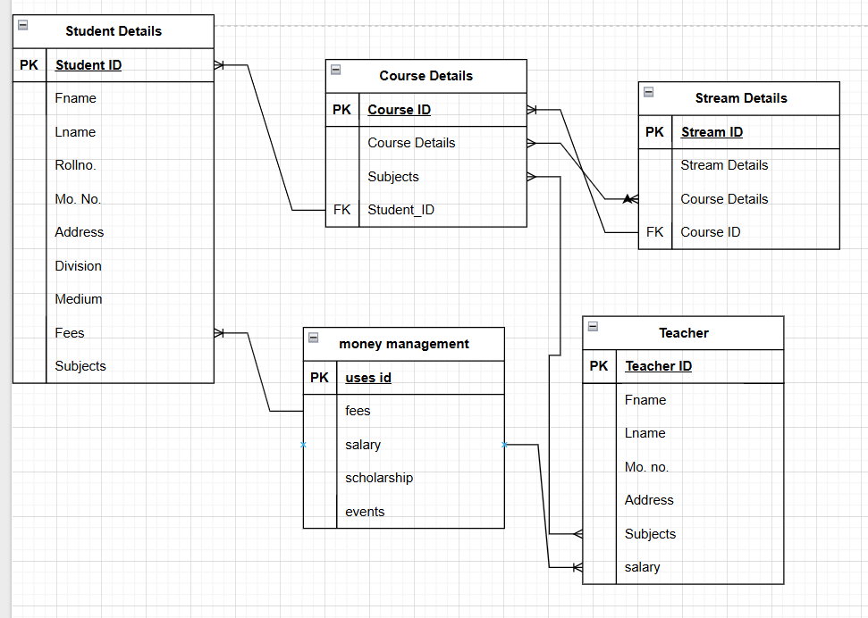

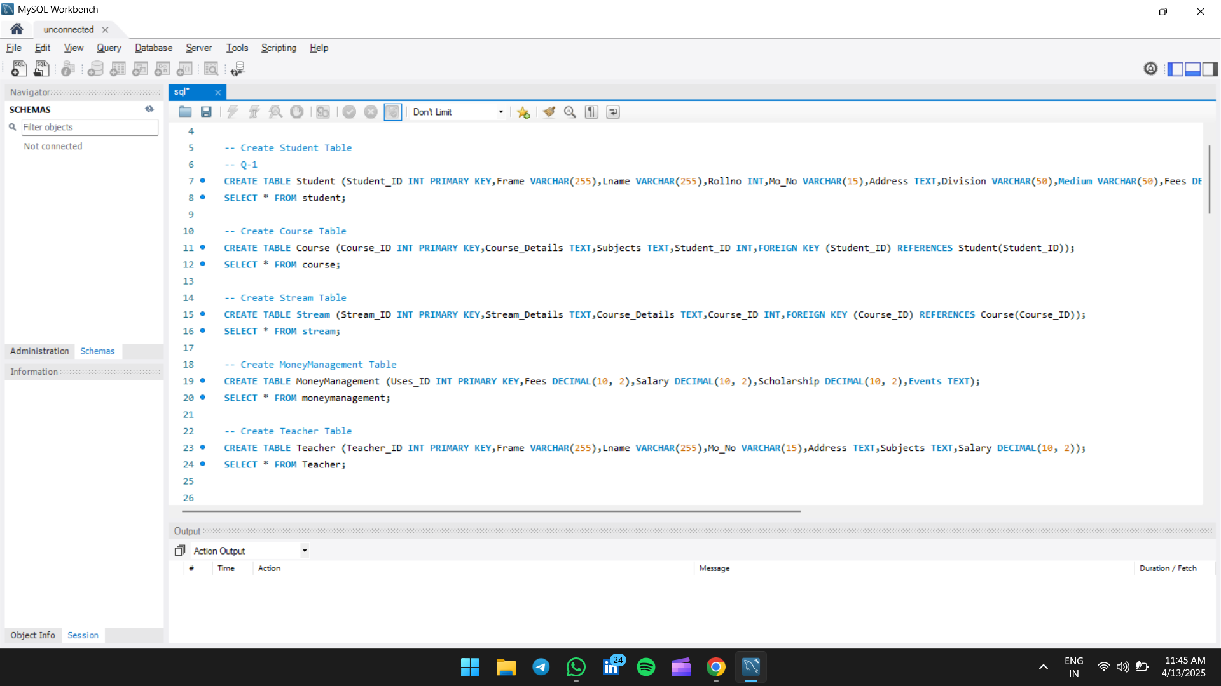

Q-2. Design an entity-relationship (ER) diagram for a Hospital Management System and translate it into a relational database schema.

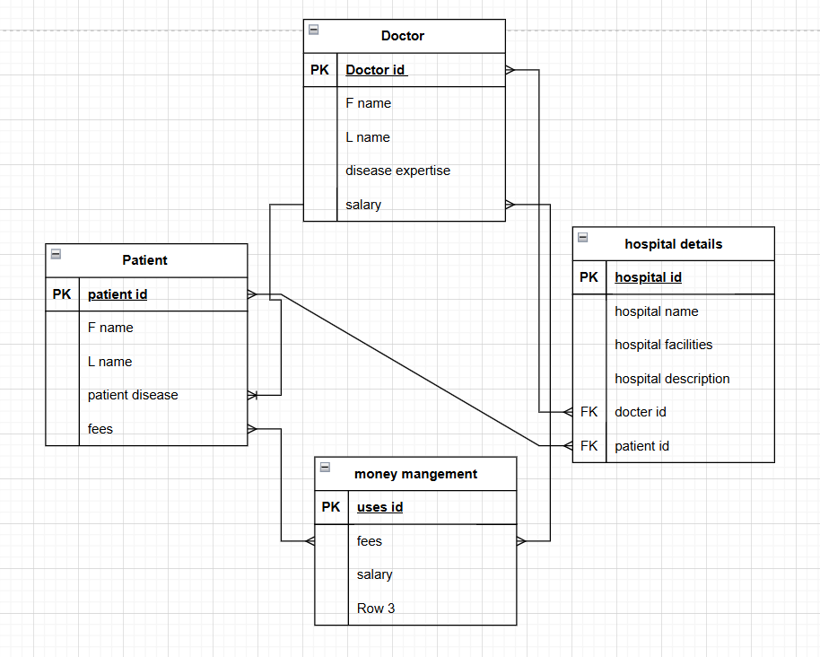

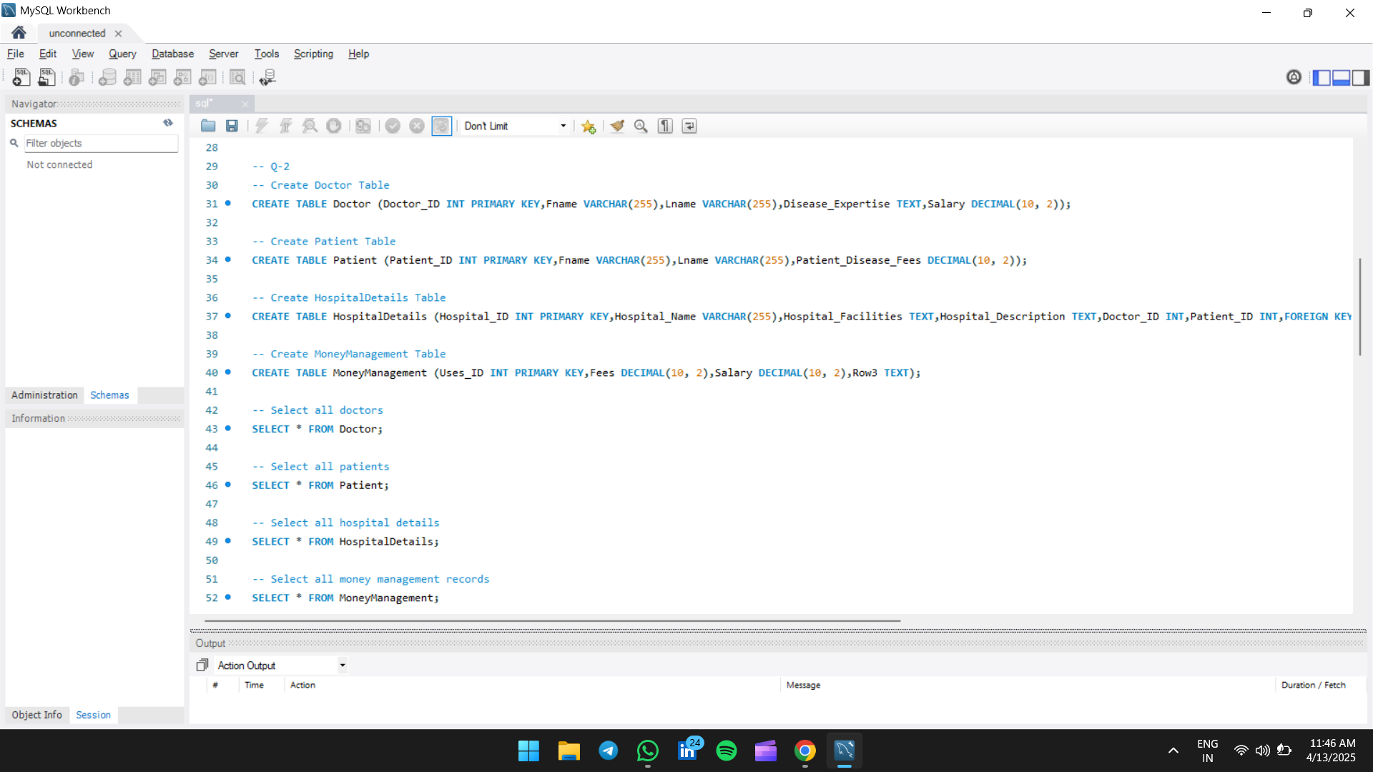

Q-3. Design an entity-relationship (ER) diagram for a Library Management System and translate it into a relational database schema.

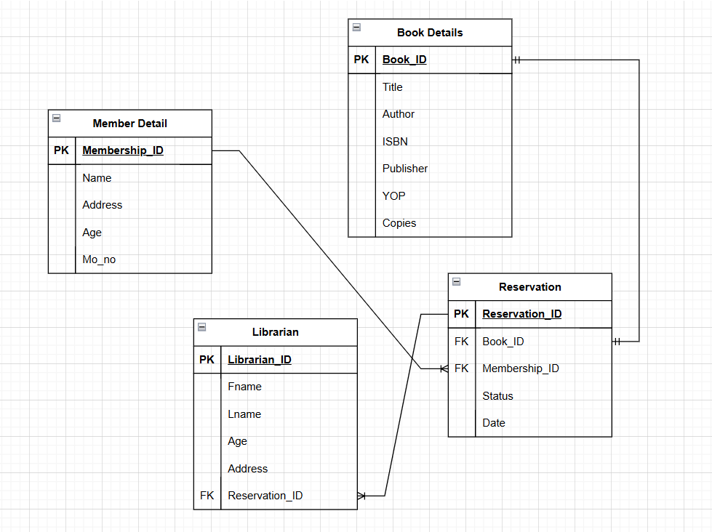

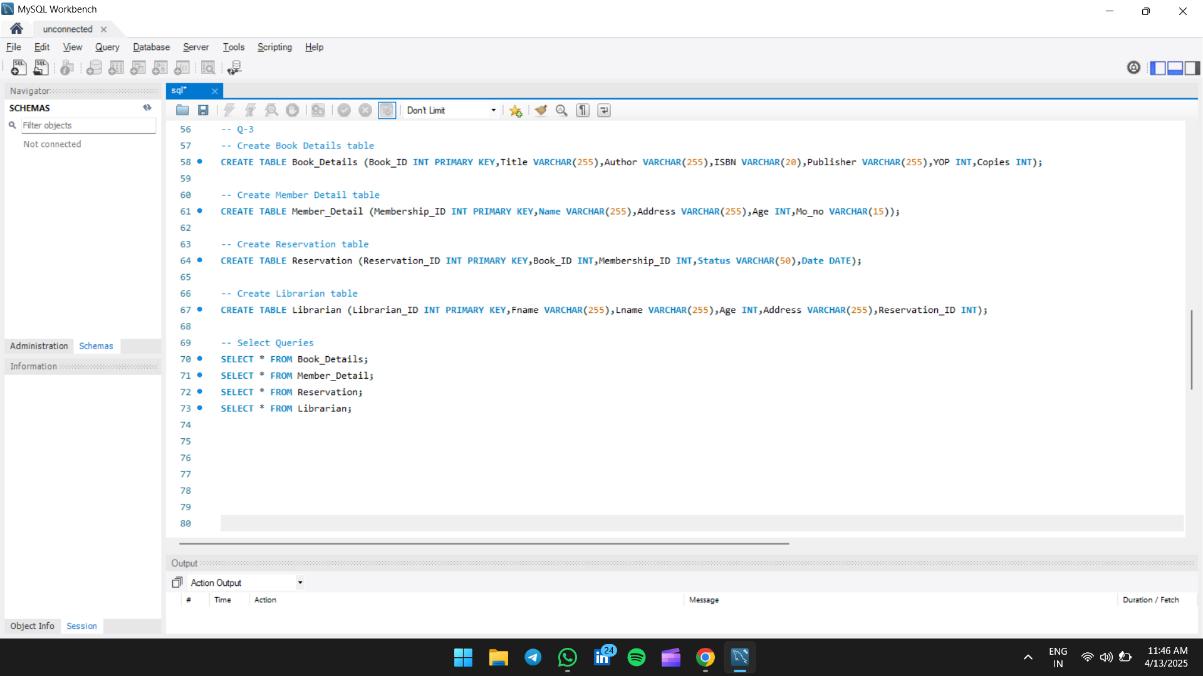

Q-4. Design an entity-relationship (ER) diagram for a Zomato services system and translate it into a relational database schema.

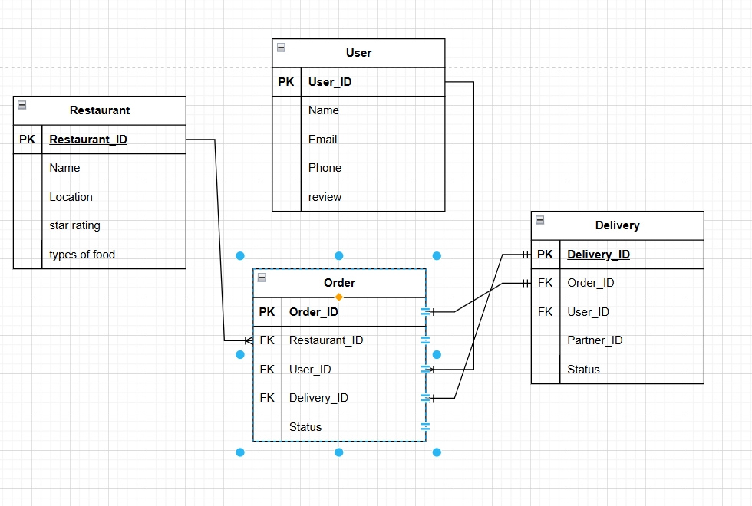

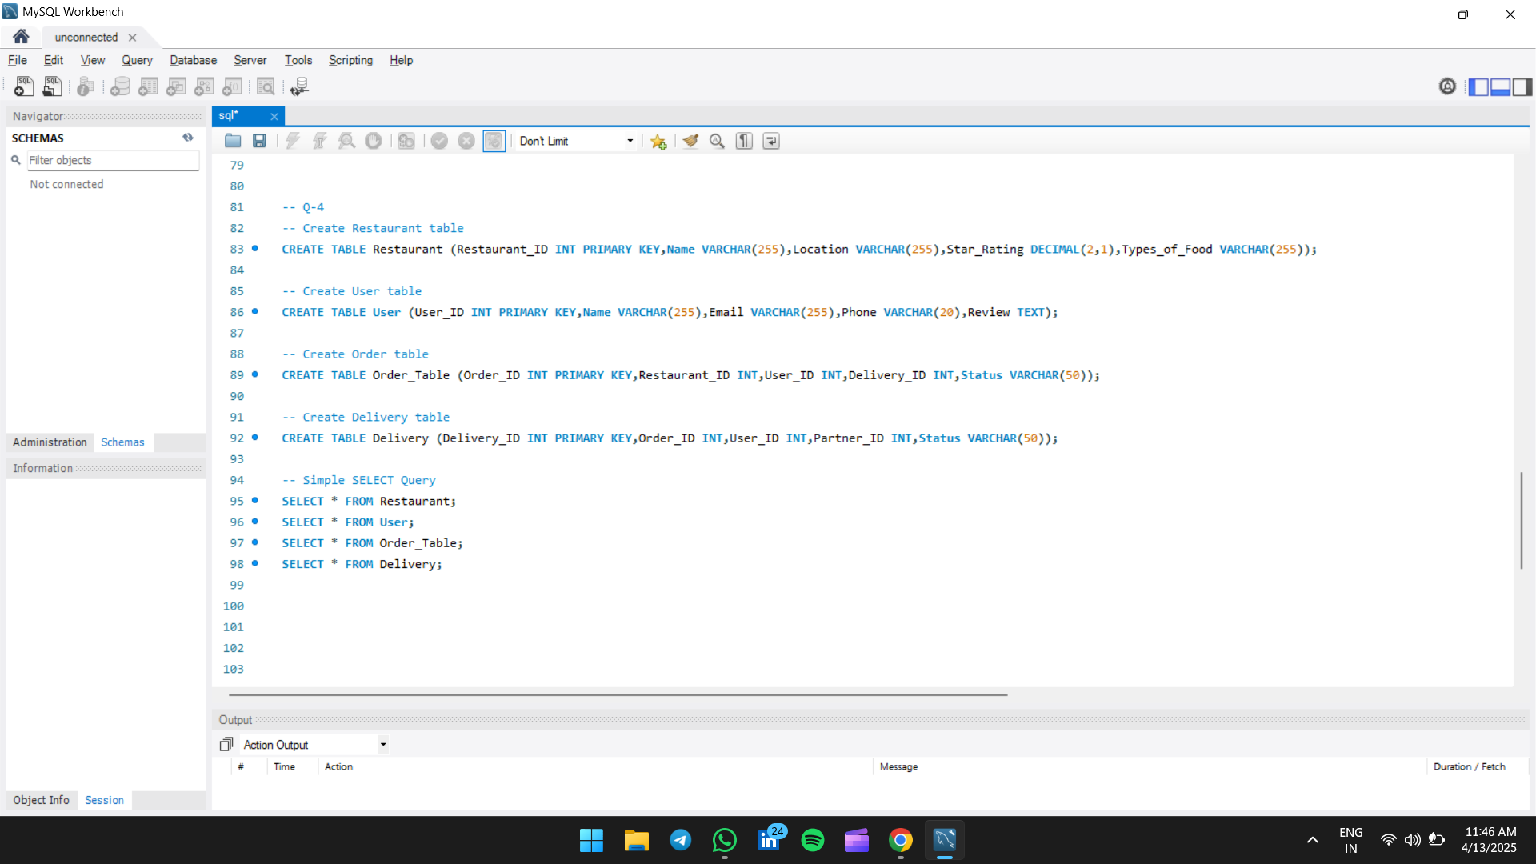

Q-5. Design an entity-relationship (ER) diagram for an Amazon services system and translate it into a relational database schema.

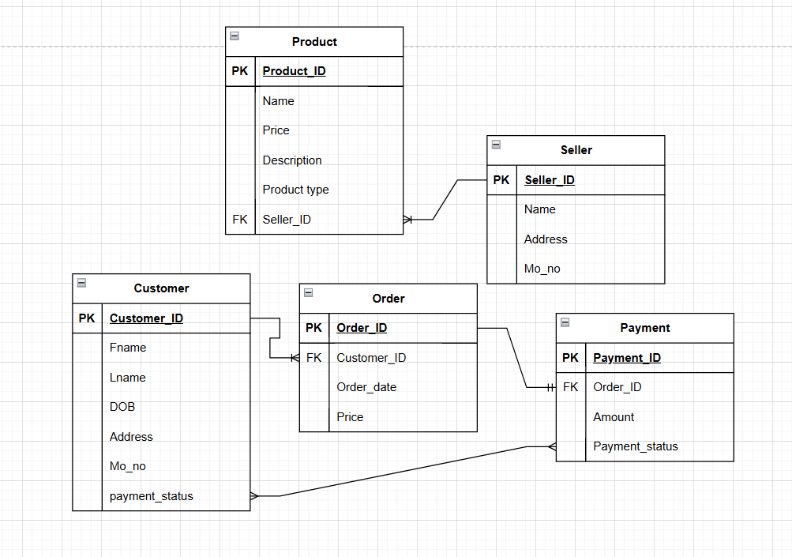

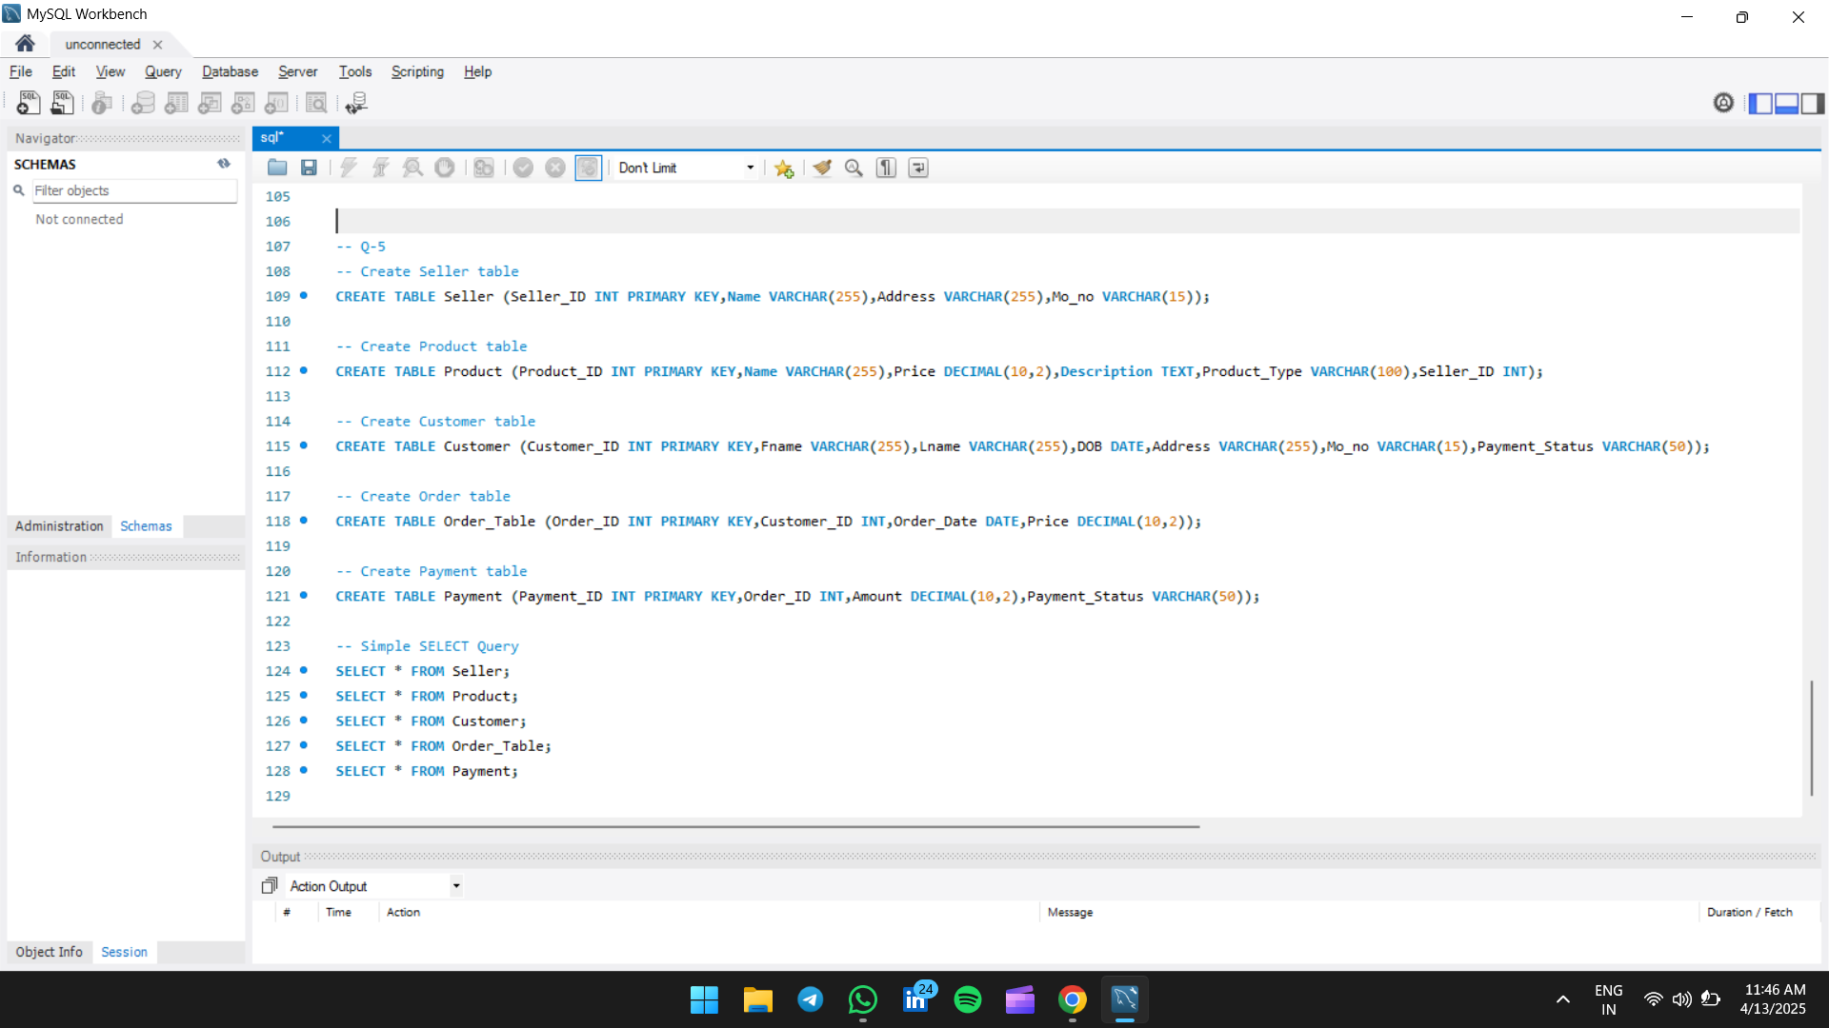

Q-6. Design example of SQL clauses (WHERE) to filter, sort, and group data.

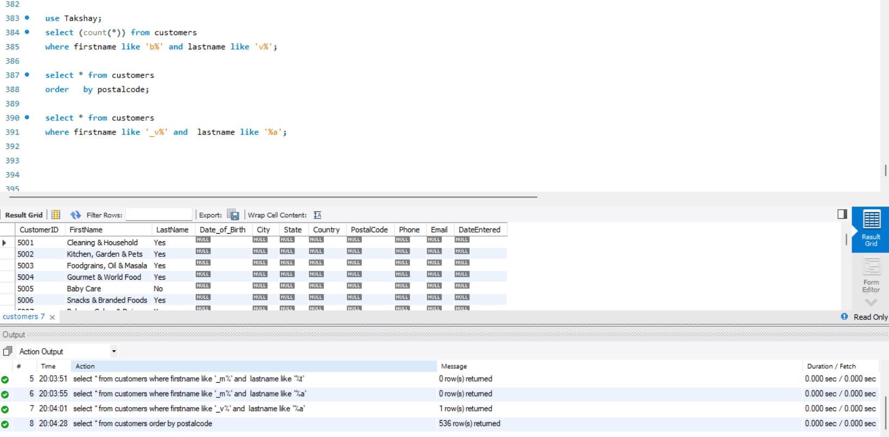

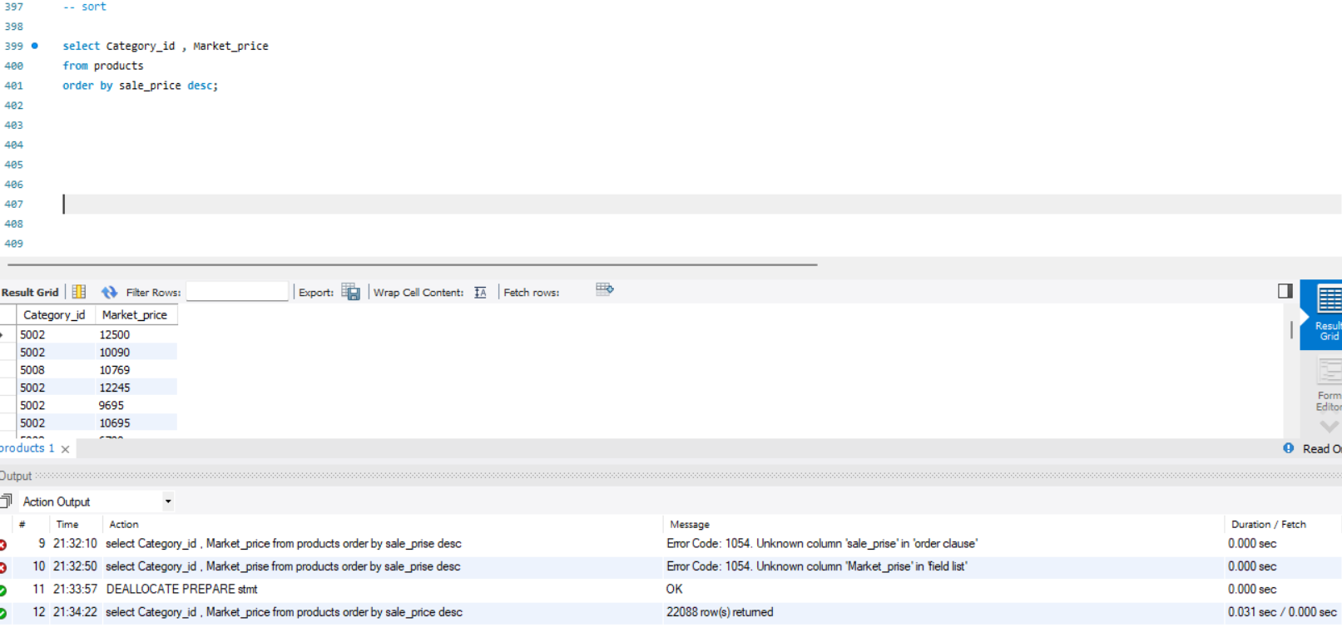

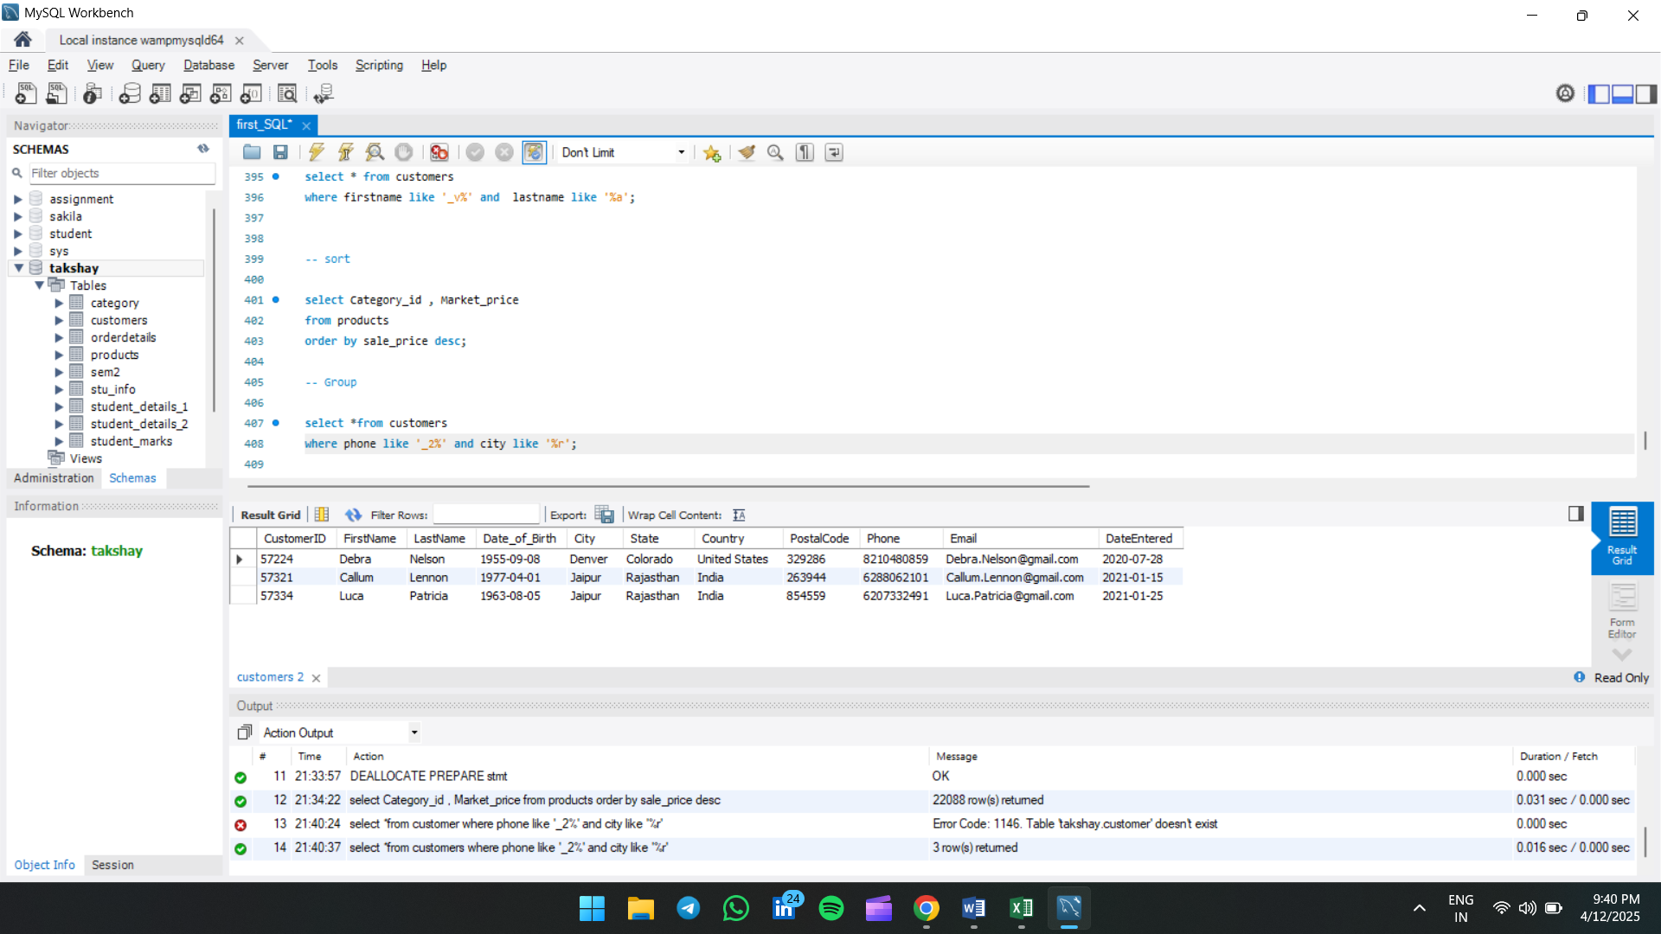

Q-7. Perform basic data manipulation operations such as inserting new records, updating existing records, and deleting records.

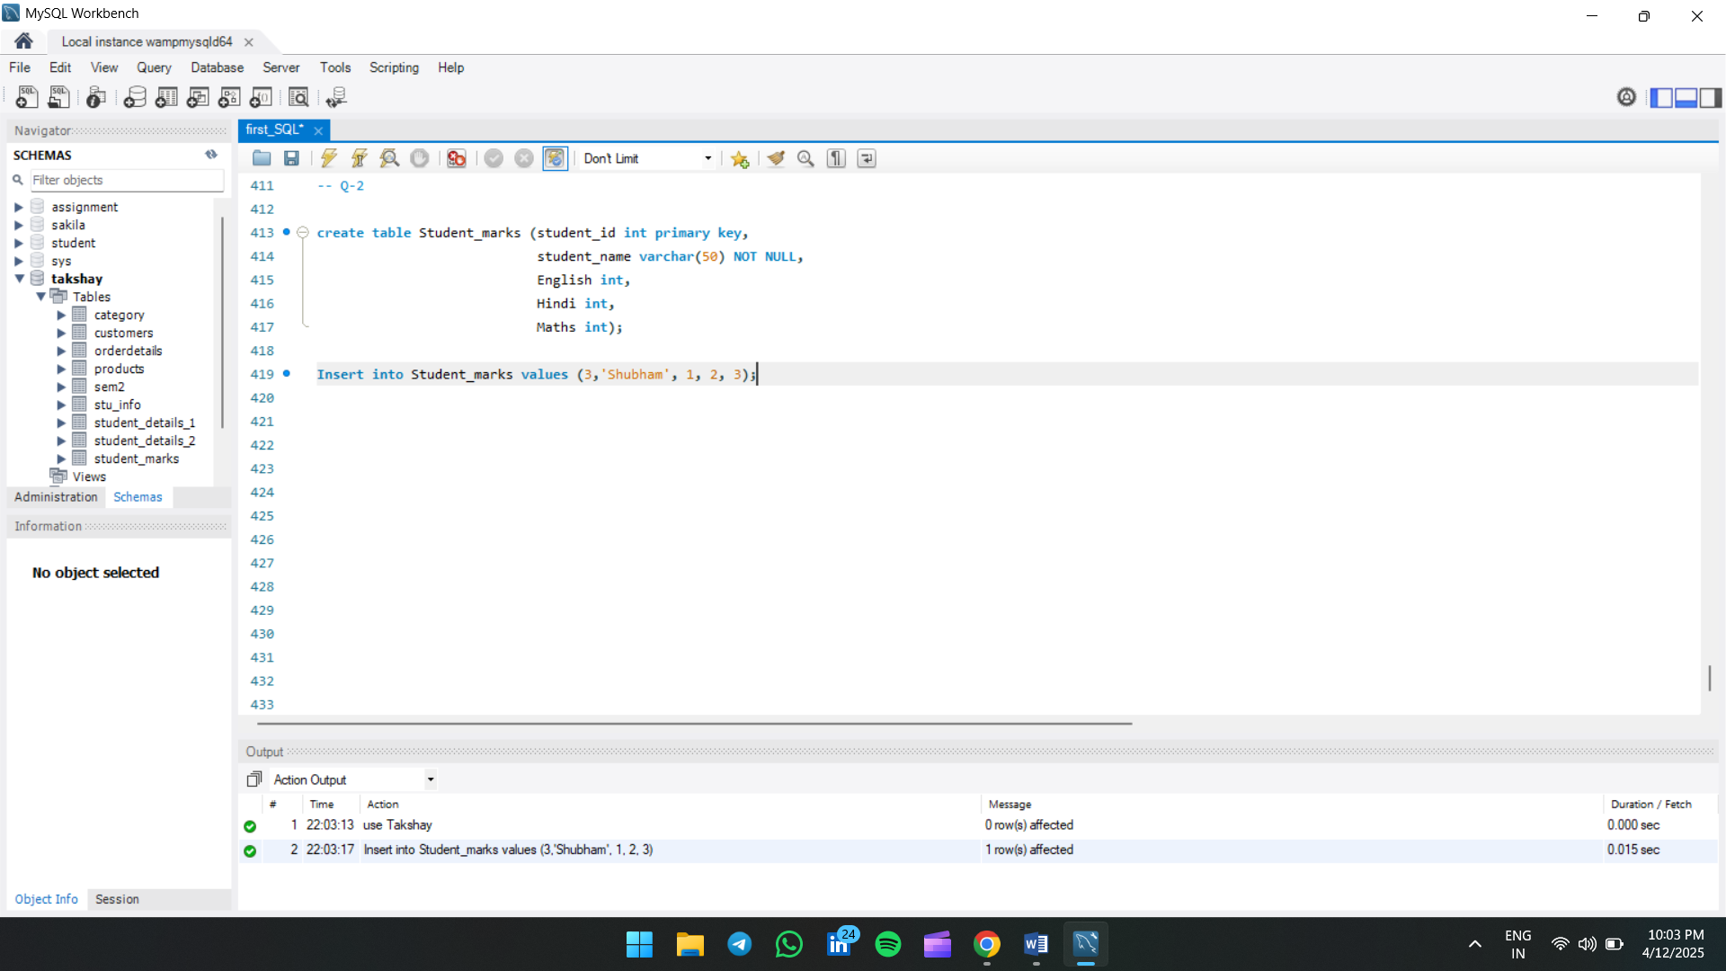

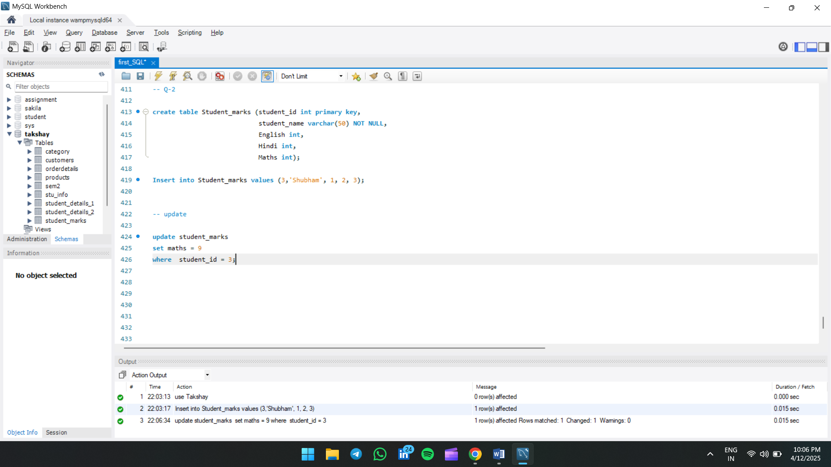

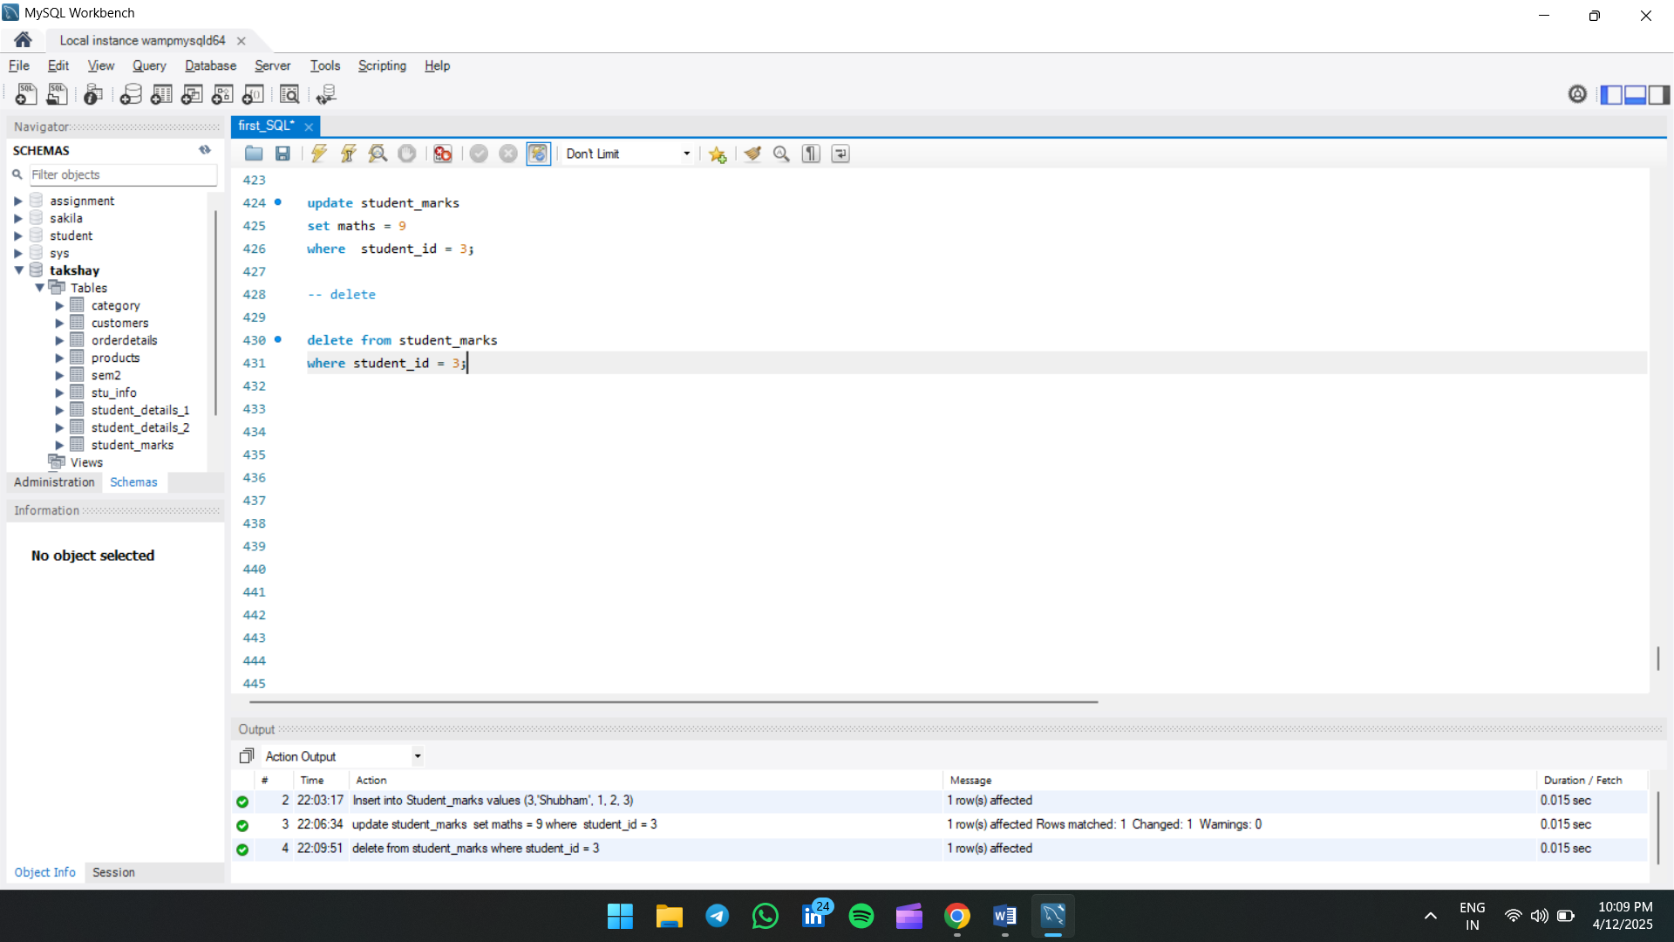

Q-8. Make a list of DDL, DML, DCL, and DQL commands.

**✅ 1. DDL (Data Definition Language)**

Used to define and modify database structure (schemas, tables, etc.)

| **Command** | **Description** |
| --- | --- |
| CREATE | Creates database objects like tables, views, etc. |
| ALTER | Modifies existing database objects |
| DROP | Deletes database objects |
| TRUNCATE | Removes all records from a table (faster than DELETE, no rollback) |
| RENAME | Renames a table or a column |
| COMMENT | Adds comments to the data dictionary |

**✅ 2. DML (Data Manipulation Language)**

Used to manage data within tables (insert, update, delete records)

| **Command** | **Description** |
| --- | --- |
| INSERT | Inserts data into a table |
| UPDATE | Updates existing data in a table |
| DELETE | Deletes data from a table |
| MERGE | Combines INSERT and UPDATE operations |
| CALL | Calls a stored procedure |

**✅ 3. DCL (Data Control Language)**

Used to control access to data in the database

| **Command** | **Description** |
| --- | --- |
| GRANT | Gives user access privileges to database |
| REVOKE | Removes user access privileges |

**✅ 4. DQL (Data Query Language)**

Used to query and fetch data from a database

| **Command** | **Description** |
| --- | --- |
| SELECT | Retrieves data from one or more tables |

Q-9. Apply to alter command in table and change the column name, drop data, change the  datatype of the column, and add the column in Table.

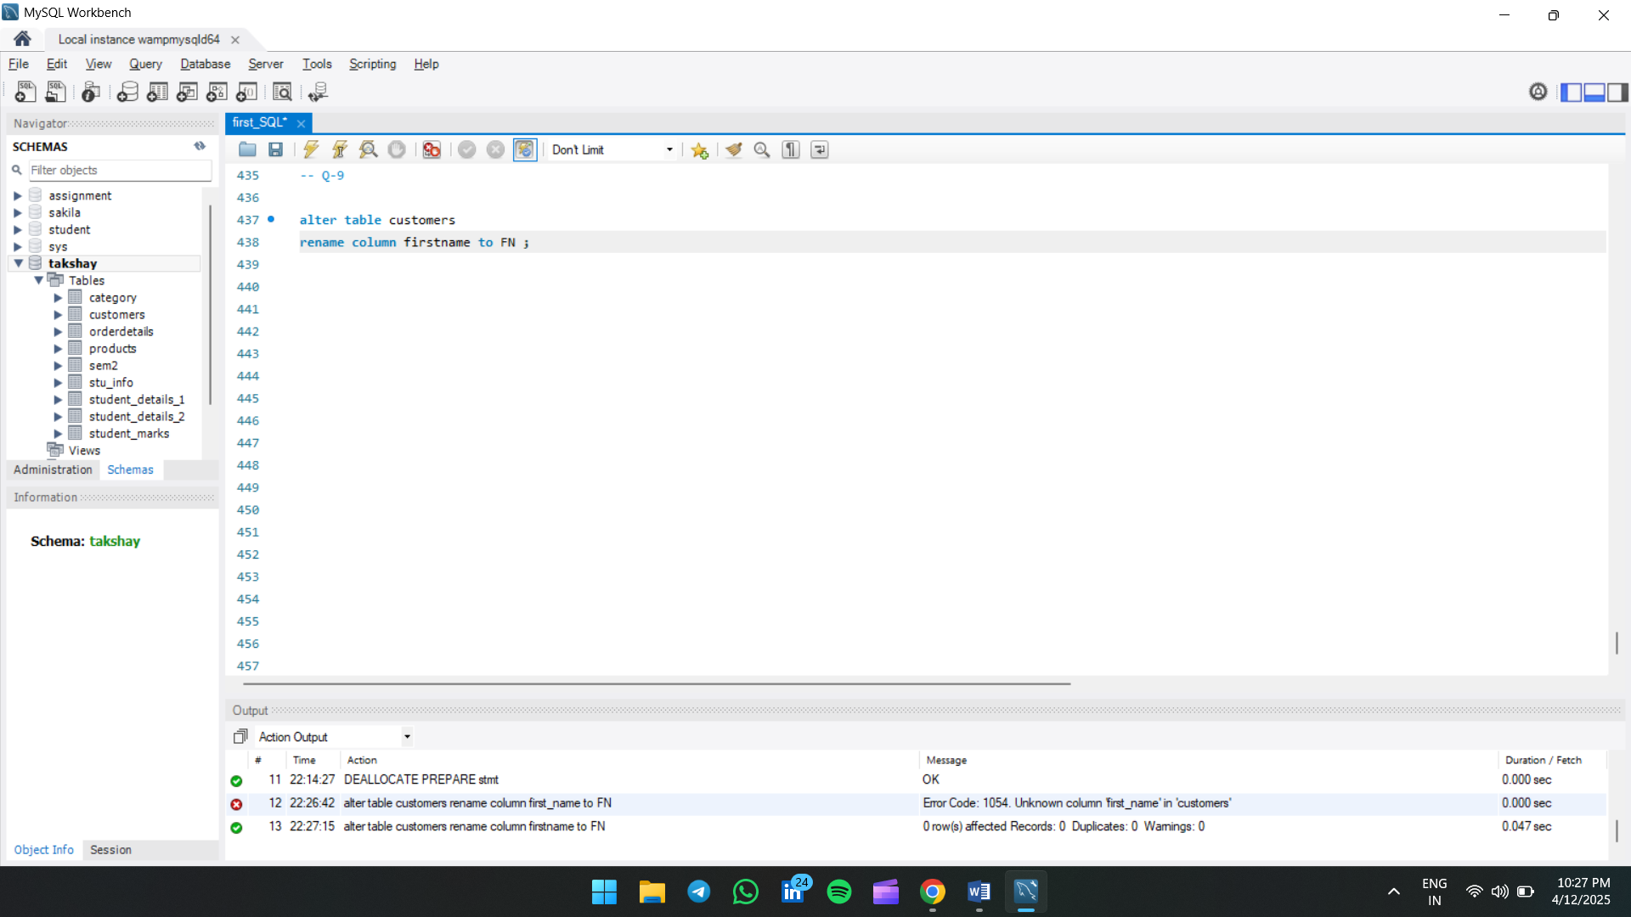

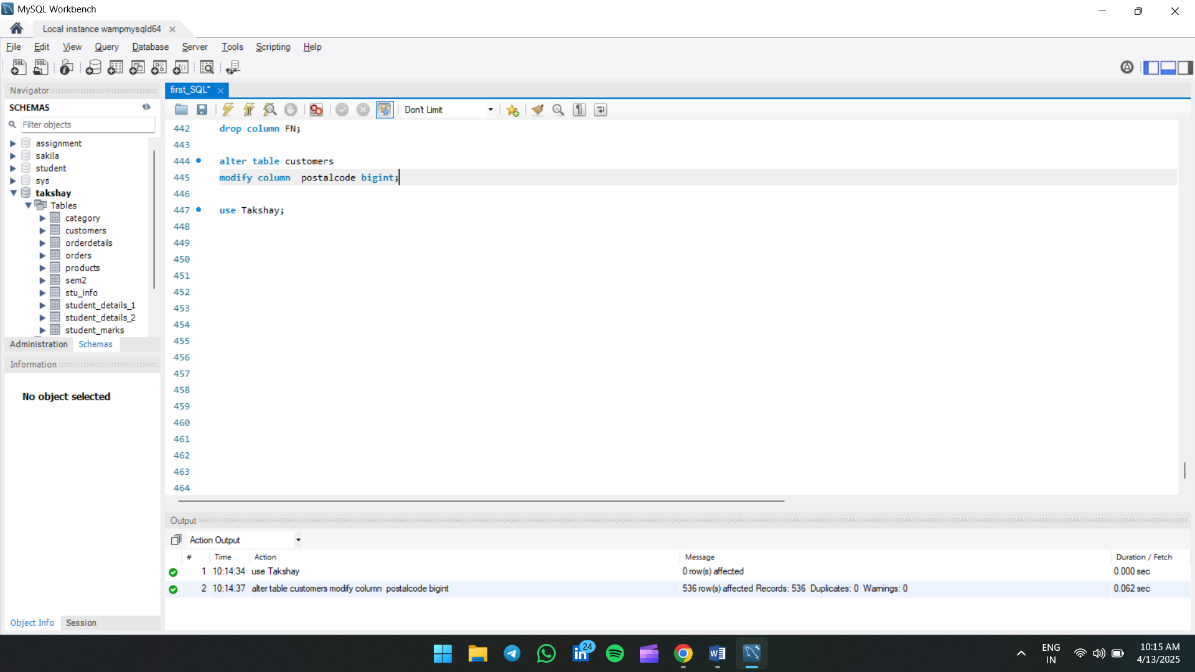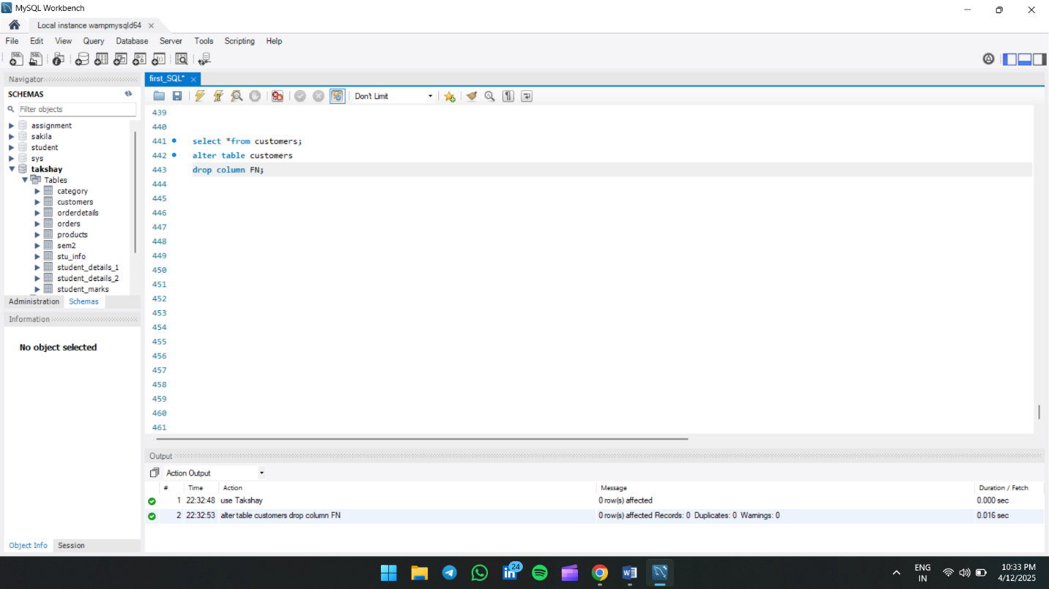

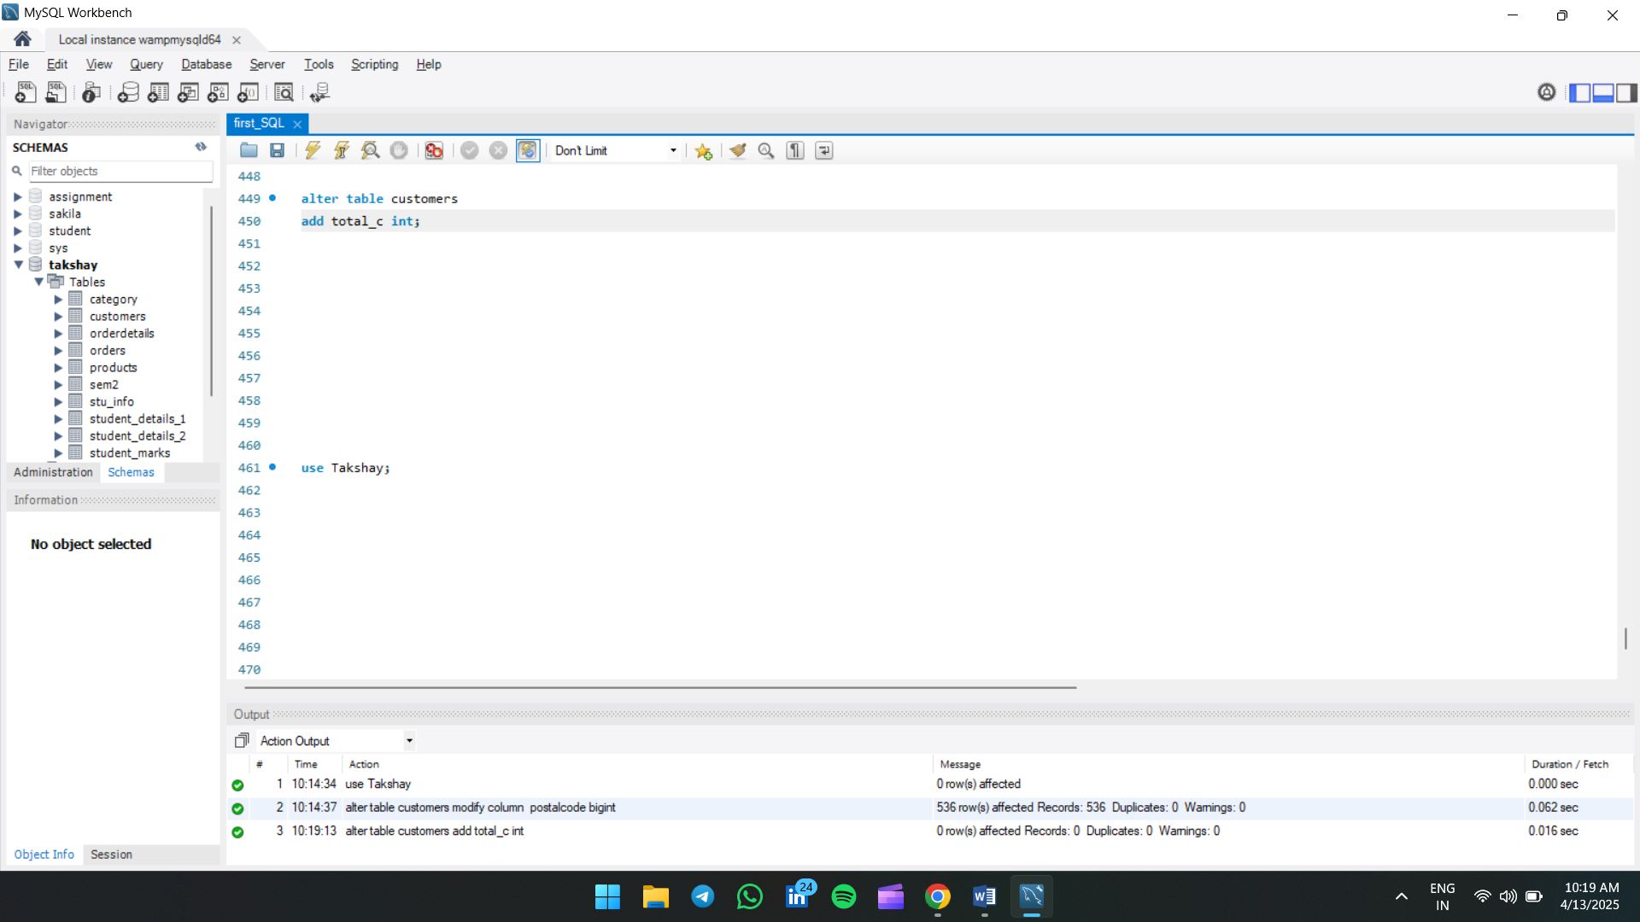

10. Practice using SQL clauses (ORDER BY) to filter, sort, and group data.

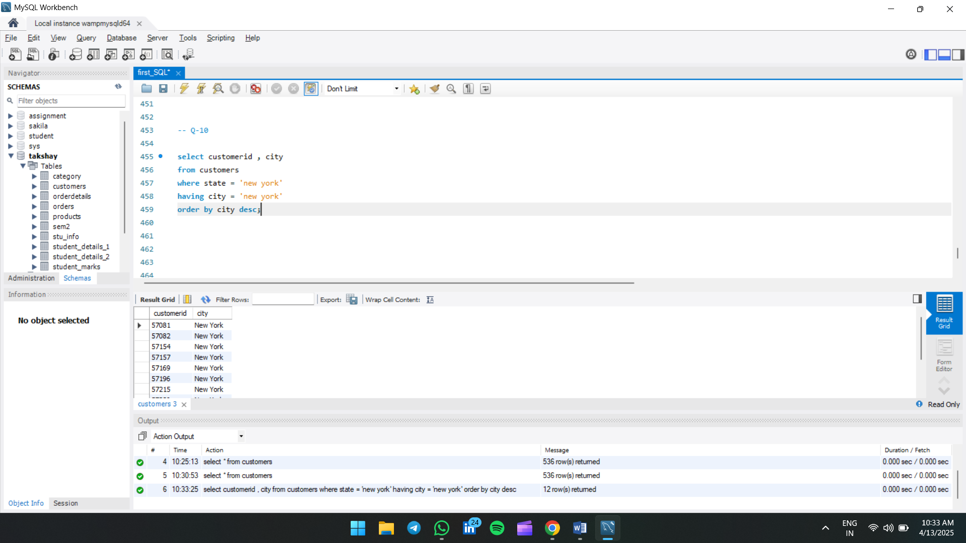

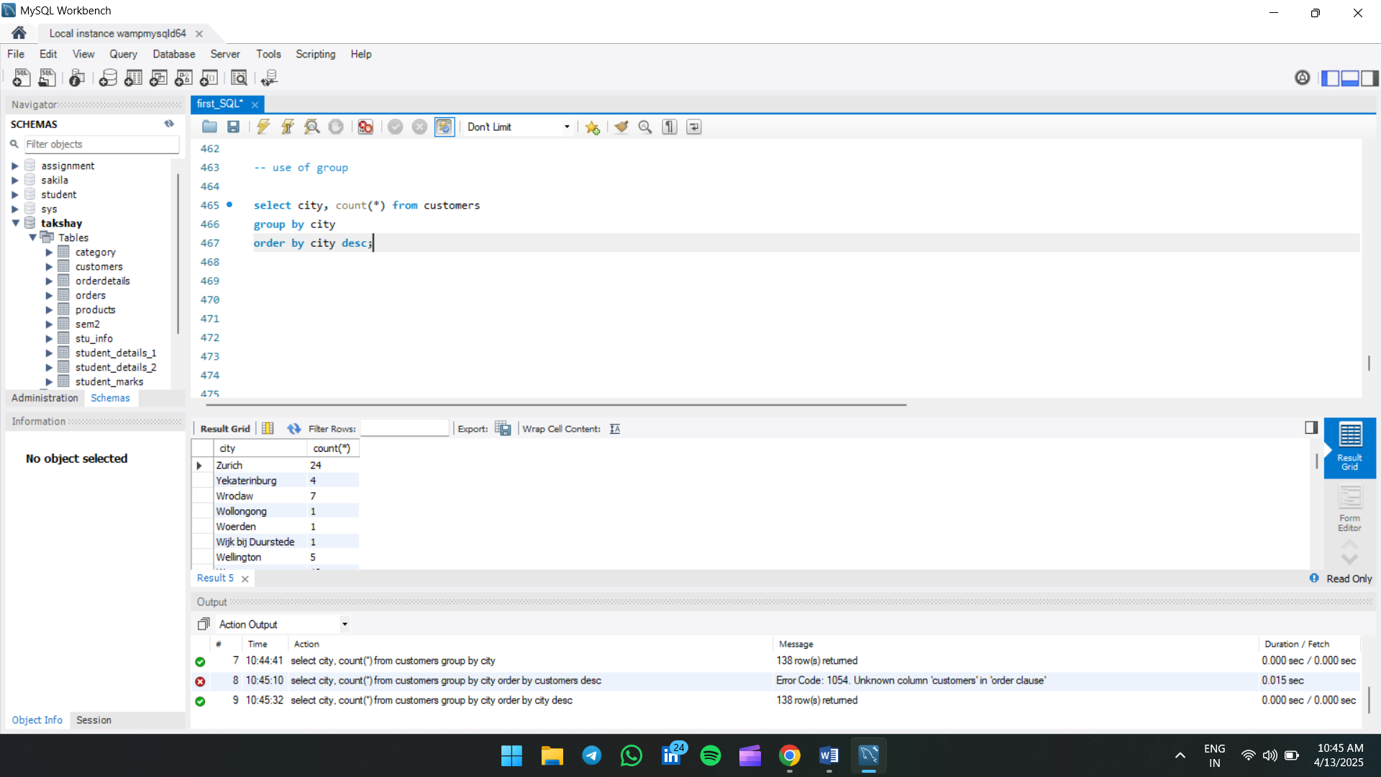

Q-11. Explore different JOIN operations (INNER JOIN) to retrieve data from multiple related tables.

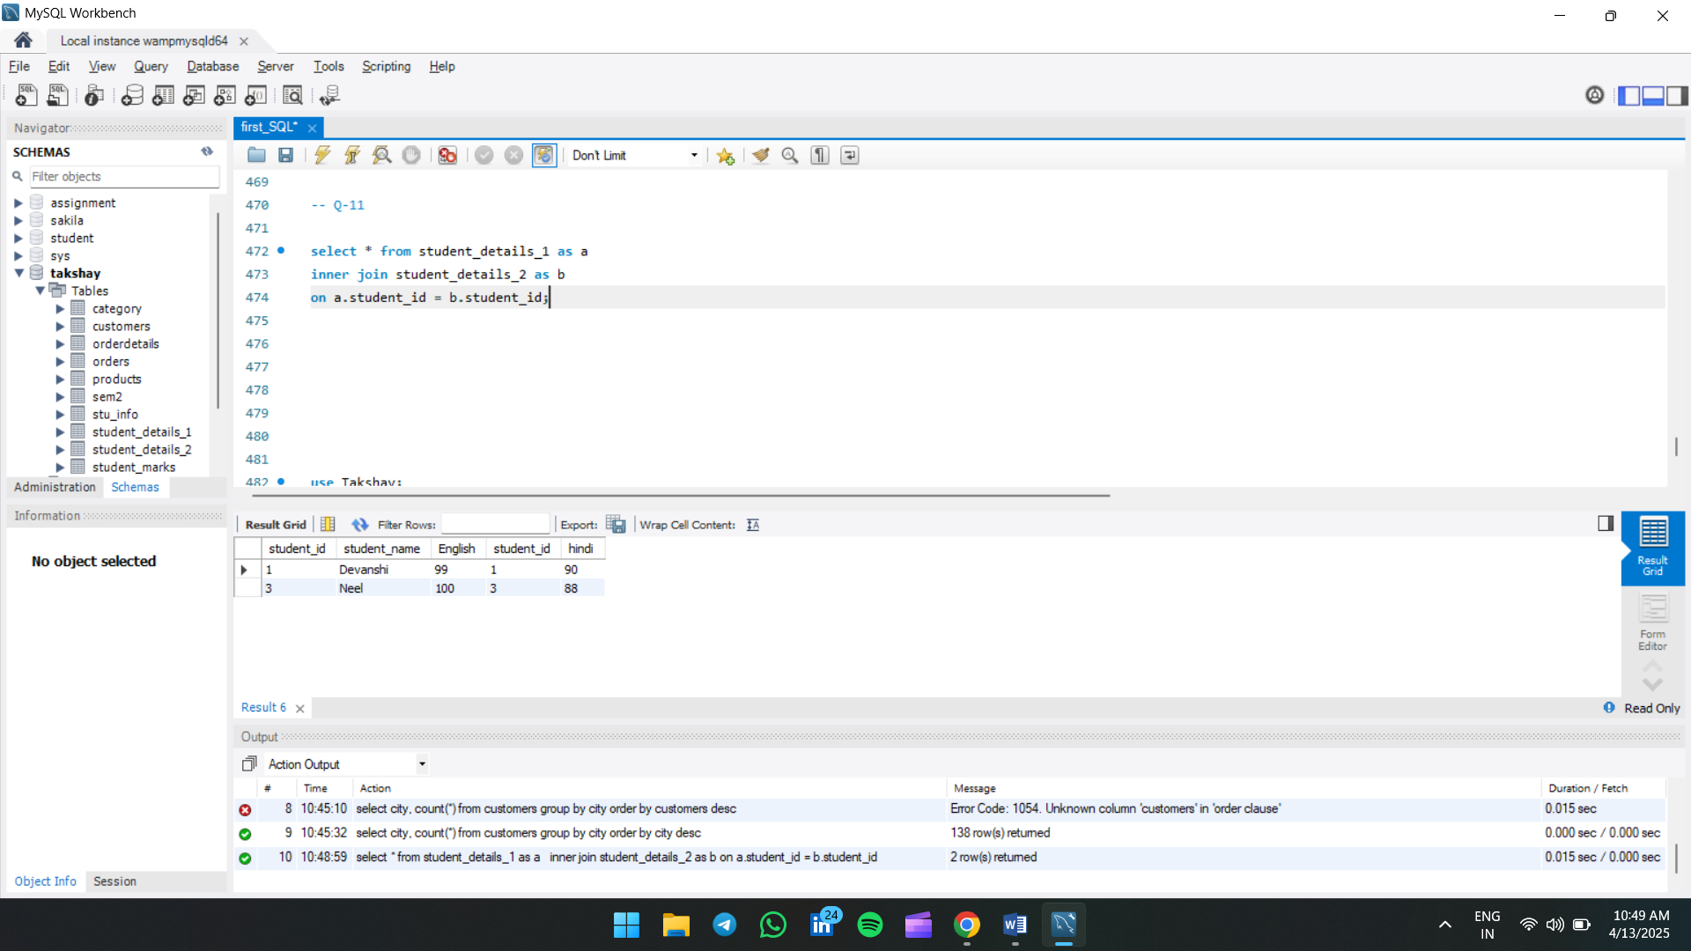

Q-12. Explore different JOIN operations (LEFT JOIN) to retrieve data from multiple related tables.

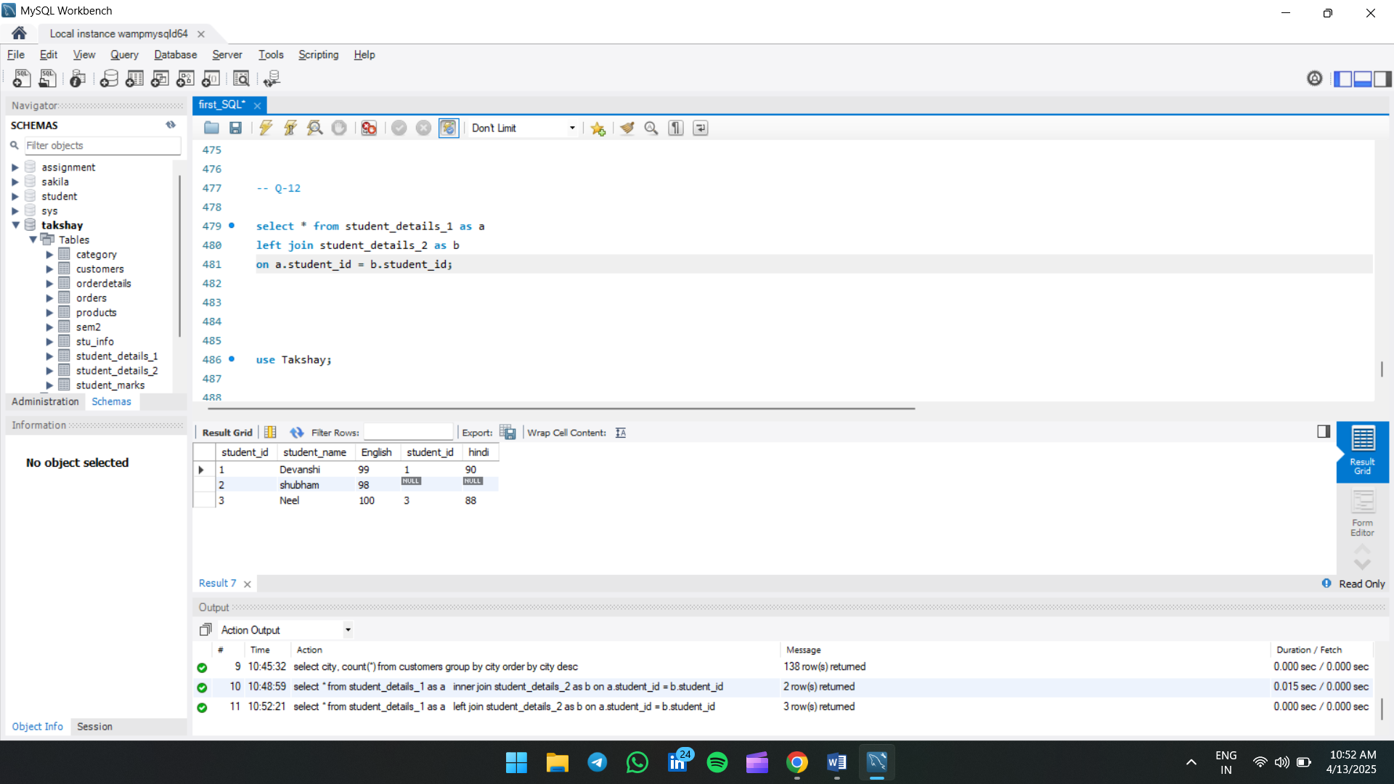

Q-13. Explore different JOIN operations (RIGHT JOIN) to retrieve data from multiple related tables.

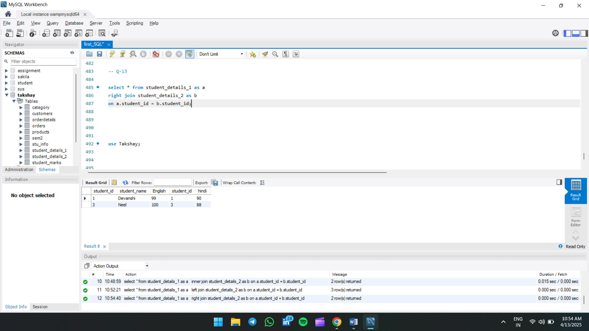

Q-14. Explore different JOIN operations (CROSS JOIN) to retrieve data from multiple related tables.

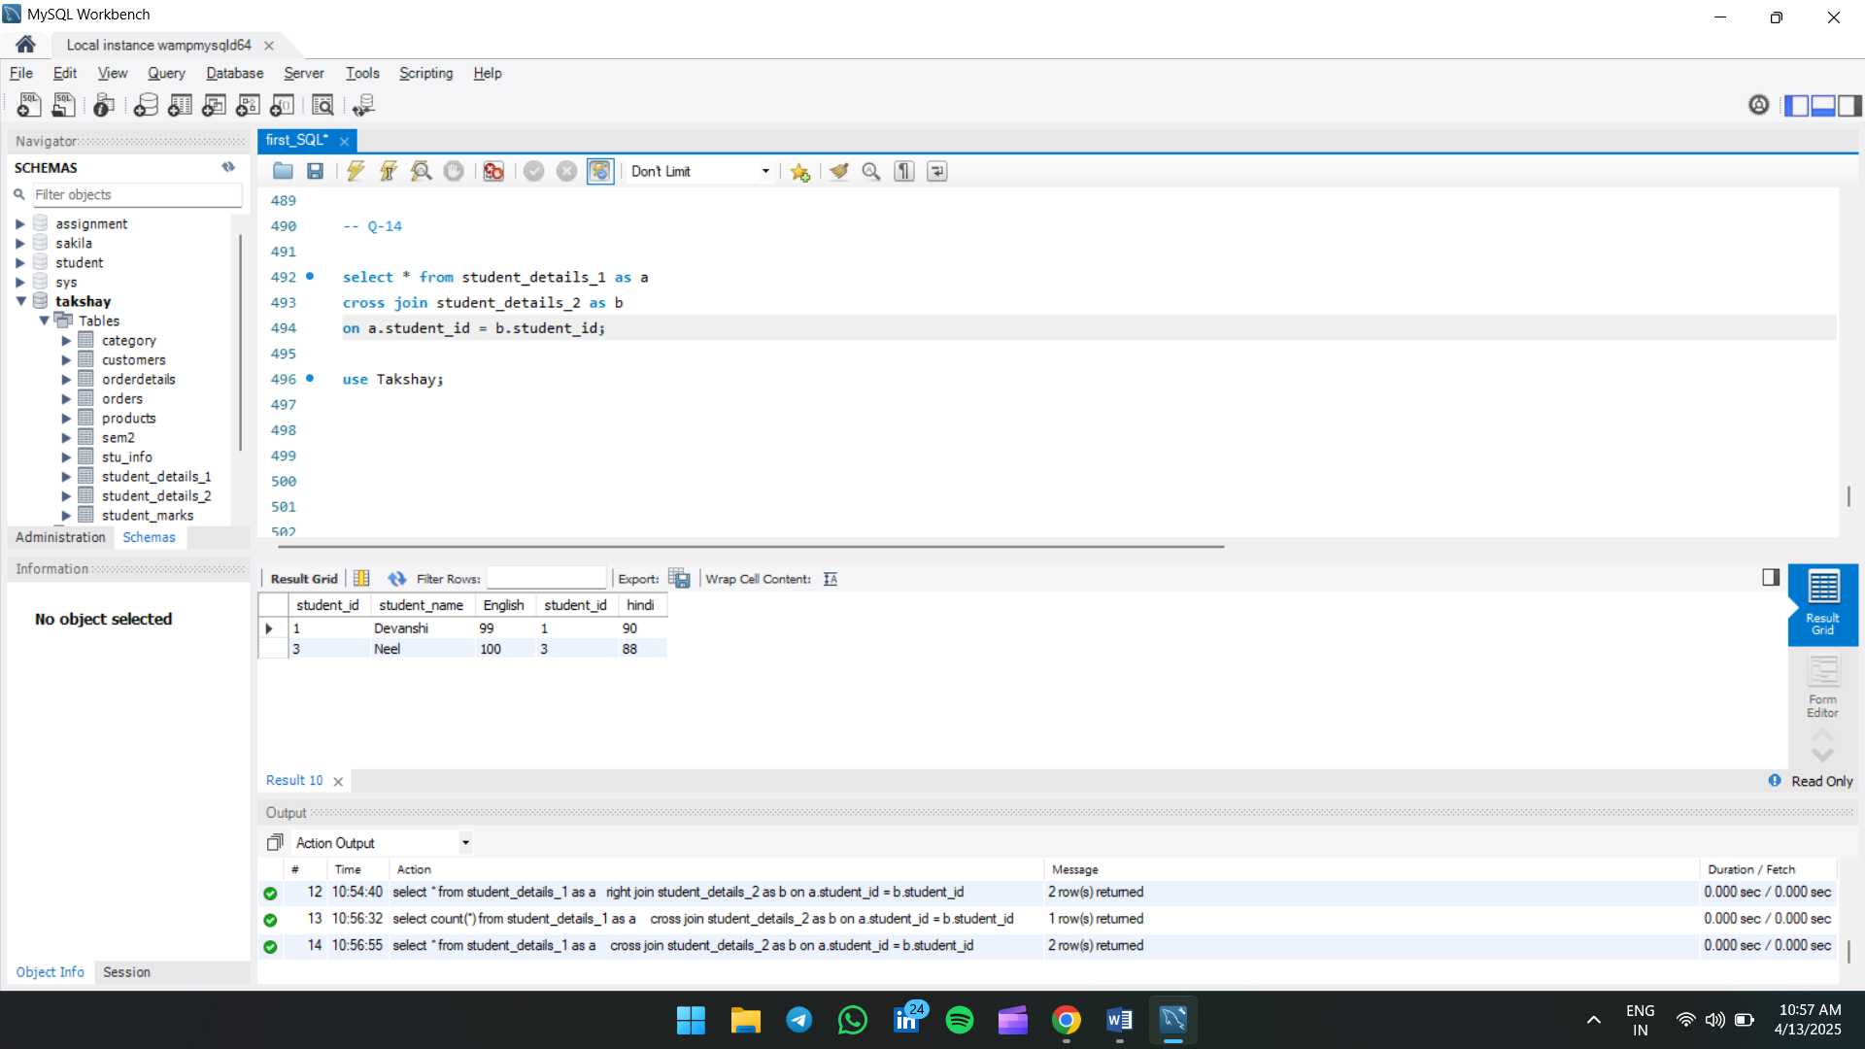

Q-15. Explore different JOIN operations (INNER JOIN, LEFT JOIN, RIGHT JOIN) to retrieve data from multiple related tables.

